Subscriber Optimization: Rosetta Stone

**Action Plan:**

The technical and business teams worked together to understand and answer the project proposal questions in a cohesive and efficient manner. Doing so resulted in the powerpoint presentation provided. The technical team made an effort dissecting the data using unsupervised machine learning models however this attempt did not prove fruitful as further discussed in the **detailed analytical plan**. The business team made use of power tools for exploratory data analysis such as Tableau in addition to their business background in working through their set of questions. Their efforts and the outcome of their work is also detailed below in the **detailed analytical plan**.

**Supporting Information:**

Please refer to the following external resources the team used in the process of working on this project:

1. [Available Languages | Rosetta Stone Support](https://support.rosettastone.com/s/article/What-languages-are-available-for-Rosetta-Course-HD-for-iPad-7774?language=en_US)
2. [FluentU | 7 Rosetta Stone Alternatives](https://www.fluentu.com/blog/rosetta-stone-alternative/#toc_6)
3. [Duolingo Effectiveness Study](http://static.duolingo.com/s3/DuolingoReport_Final.pdf)
4. [Business of Apps | Language Learning App Revenue and Usage Statistics](https://www.businessofapps.com/data/language-learning-app-market/)

**Division of Work:**

Given the scope of this project, the team had to devise a plan and work together ensuring that the work done would not get done alone but also done well. The first steps taken were a general assessment of the provided material. This was the assignment specs alongside the provided datasets. Each team member took the effort to look the information over and create their own understanding of the data prior to working together. This was beneficial in that it not only helped ensure each team member had a basic understanding of the information, but also allowed for some level of personal creativity. That is, each team member was able to create their own narrative and understanding of the data without any external influence.

Once the team members had their own data understanding they came together and discussed their findings. This process was done in the first meeting where a running list of ideas for the different data questions posed were answered. Having this opportunity to share what each team member found was a great starting point for the true work to begin. It was decided that the group would divide themselves into a more technical team and a more business oriented team, referred to as the technical and business teams. The technical team was composed of Arman and Nathan, while the business team was Dexter, Emily, and Thalia. The technical team focused on trying to understand the data from a technical perspective while the business team created their understanding using both technical skills and business knowledge. Questions 1 through 3 of the initial project proposal were assigned to the business team while questions 4 and 5 were assigned to the technical team.

Each team member did their part in covering their respective questions, and formulated their ideas on the powerpoint presentation. This division of work felt fair and reasonable to the team as a whole and to each team member.

**Detailed Analytical Plan:**

**Determine the most valuable subscribers:**

To identify which consumers provided the most value to Rosetta Stone, we tried to understand relationships between variables that can indicate value, such as country, language, subscription length/type, auto-renewal rates, and media platforms. This helped us conclude that lifetime users were more valuable than limited users. We can see this through the relationship between user type and average purchase amount, where a lifetime subscriber spends ~$150 more than a limited user on Rosetta Stone. 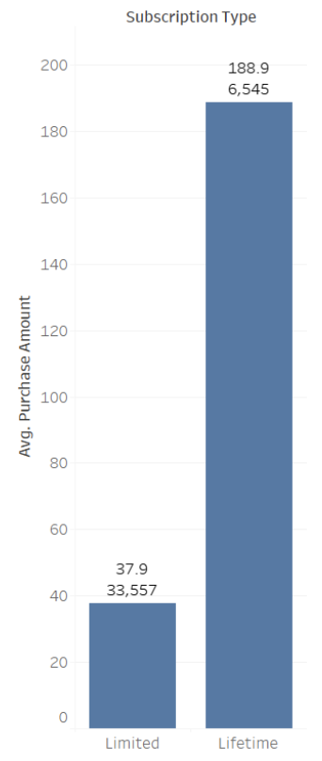

The next thing we discovered was that IOS users and US/Canada consumers were the most valuable compared to other platforms and countries. According to Rosetta Stone market research, their largest geographical customer segment are US consumers. Also, our data supports that IoS users have the highest percentage of app activity and highest renewal count. Additionally, just in general, 55% of American consumers use iPhones, therefore this is a valuable consumer segment to focus on.

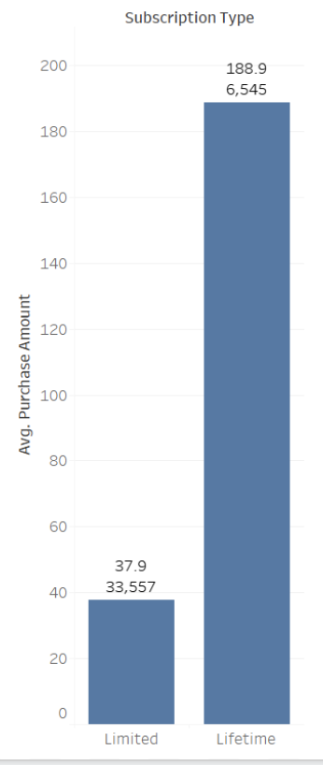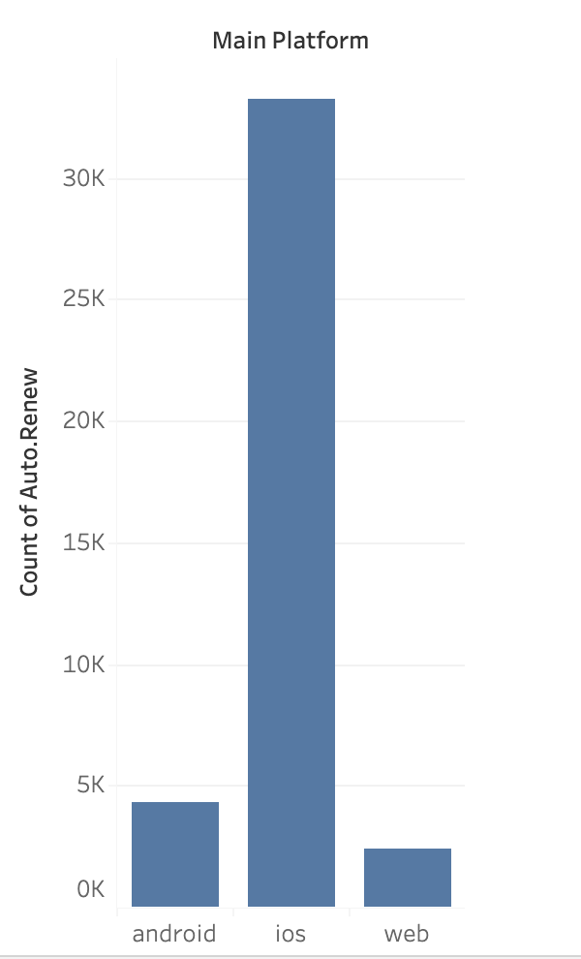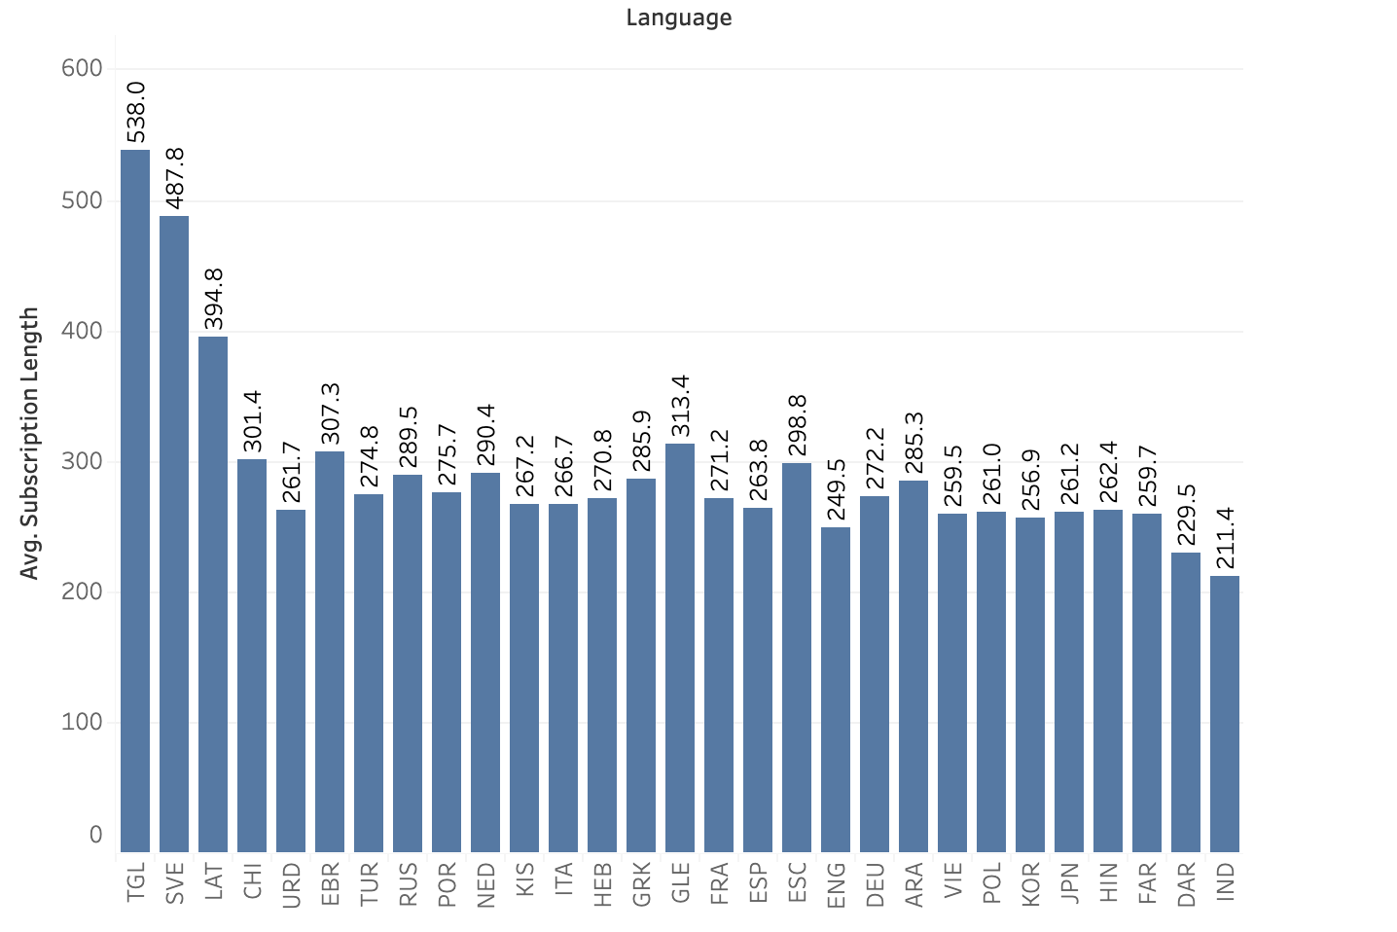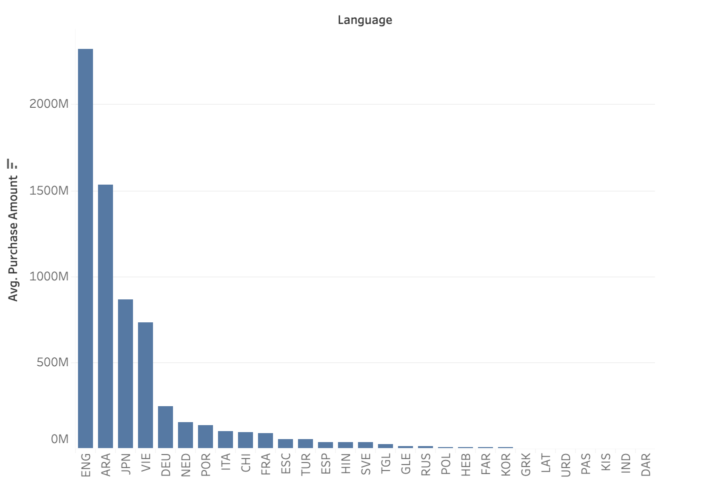

Lastly, consumers learning Tagalog, Swedish, English, and Arabic are the most valued in regards to language. Tagalog and Swedish have the highest subscription length, and English and Arabic have the highest purchase amount associated with them. These languages are valuable based on customer retention and popularity.

**Understanding the subscriber segments present in the database:**

When looking to find the different subscriber segments we tried to settle on an effective and clear means of doing so. The first step was to look at the data and take note of the different features. We have several different data features to work with and luckily, they helped us greatly. The first large segment we came across was the location based data. We have 3 large locations by which we can segment customers. Those being the US, EUR, and GBP. These different locations are useful in understanding our geographic distribution of which most are in the US. The second segment was the platform being used. The data has both app based and web based user data. This was a quick and easy user segment to isolate, as how the user interacts with the service is important and easy to identify. The last segment was the type of plan purchased. This segment holds the free trial users, the monthly plan users, and the lifetime plan users. Each of which, as prior, are easy to identify and important when discussing how to target different segments.

**Identify the most likely subscribers who could be sold additional products or services:**

Identifying the most likely subscribers who could be sold additional features was an easy one for the team. Given the strong business oriented nature of the team course the data acted more as a means of endorsing the subscriber segment selected as opposed to discovering it. The team felt that the easiest group to upsell would be those who are the easiest to interact with. Those ended up being those who received the most emails. This of course makes sense as getting more and more emails would result in more clicks. This was also found to be true in the correlation matrix made which can be found in the code pdf. The team also felt that upselling around the holidays is a good opportunity as potential customers are more likely to look to the service as a gift for themselves or others. It should be noted that the free trial users are potentially a gold mine for new users. They are customers who are willing to use the service but not yet convinced to endorse the service, making them a great demographic to attempt capturing.

**Identify the subscriber profile of those not continuing with their usage of the product and identify the barriers to deeper subscriber engagement where possible:**

This section ties in somewhat closely with the section above regarding the best subscriber segment to upsell. The data here was once again more so used to confirm suspicions as opposed to finding the segment itself. The team felt that the subscribers who would not continue with their service are those who use lifetime subscriptions. This might be counterintuitive however, lifetime subscribers buy the service once and then don’t make purchases one again. This makes it hard to sell them more services. Another subscriber profile we felt to be susceptible to not continuing their subscription was the free trial users. These users are, as mentioned above, a great segment to potentially upsell too; however they are also potentially users who simply sign up to try the service and have already decided to not subscribe afterwards. The best way to engage with these potential customers is to increase the efforts and frequency of communication through emails, and app notifications. The data helps to back that more outreach results in more interaction and that finally results in more potential customers.

**Outline any business relevant opportunities that are present from your analysis of the data not covered above:**

Lastly, we get to the continued opportunities present for Rosetta Stone. The team found that this can be broken down into 2 different conversations- exploring competitor offerings, and ensuring continued market control. Rosetta Stone needs to ensure that they take into account the offerings made by competitors in the language learning market sector. These include services such as Duolingo, Babbel, and Memrise which offer aspects such as community engagement, explicitly taught grammar, and crowdsourced knowledge respectively. In fact, in a 2012 study titled “Duolingo Effectiveness Study” done by Roumen Vesselinov, PhD from City University of New York and John Grego, PhD from University of South Carolina, it was found that 34 hours of Duolingo was equivalent 1 semester of university level language education.

In addition to market sector competition, Rosetta Stone needs to continue their overall market control. They have a strong hold on the more professional aspect of language learning but that is quickly being taken over by app based learning. App based learning offers the “convenience” factor. This can be seen in that only 12% of the $8.21 billion sector comes from web based learning services according to Meticulous Research and Markets and Markets. This is compounded by the fact that Duolingo and Memrise currently have the strongest market control.